AIM: To implement the Random Forest Classification algorithm using Python to predict students' results based on their hours studied, attendance, and assignment scores.

ALGORITHM:
1.Start.
2. Import the required Python libraries.
3. Load the data.csv dataset.
4. Remove extra spaces from column names.
5. Select Hours studied, Attendance, and Assignment as input features.
6. Select Result as the target variable.
7. Split the dataset into training and testing sets.
8. Create a Random Forest Classifier with 100 decision trees.
9. Train the model using the training data.
10. Predict the results using the testing data.
11.Calculate accuracy, confusion matrix, and classification report.
12.Plot the feature importance graph.
11.Display the evaluation results and graph.
12.Stop

OUTPUT:
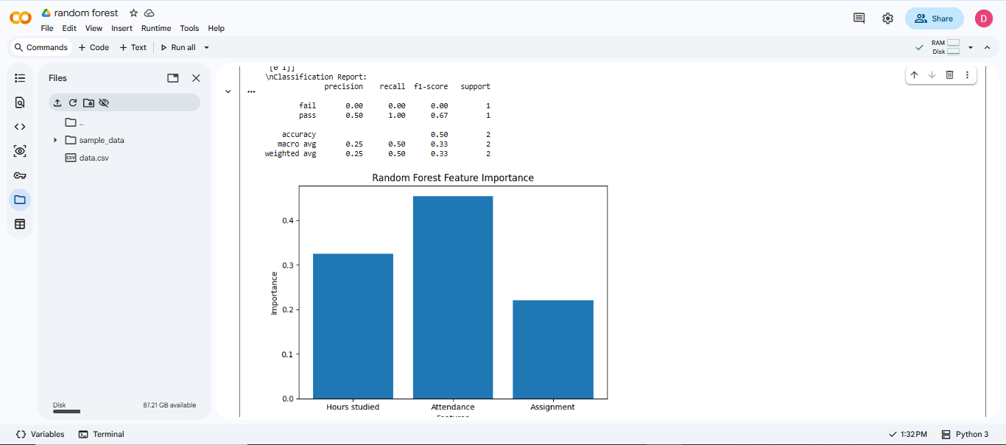

RESULT: Thus, the Random Forest Classification algorithm was successfully implemented to predict students' results based on their study hours, attendance, and assignment scores. The model's performance was evaluated using accuracy, a confusion matrix, and a classification report.

